Project Plan: Self-Driving AI to handle off-road terrain

Contents

Project Schedule 0

Info: 0

Project Management Methods: 0

Method: 0

Reasons: 0

Required Tools: 0

Report: 0

Program Development: 0

Deliverables/Criteria: 0

Criteria: 0

Success criteria 0

Links 1

# Project Schedule

1. 21st Sep
2. 28th Sep
3. 5th Oct

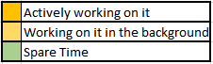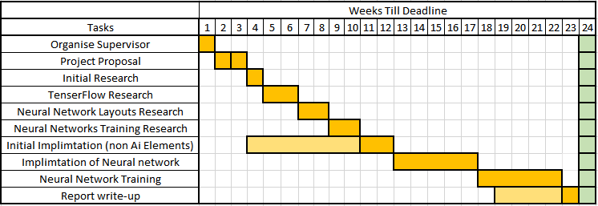

1. 12th Oct
2. 19th Oct
3. 26th Oct
4. 2nd Nov
5. 9th Nov
6. 16th Nov
7. 23rd Nov
8. 30th Nov
9. 7th Dec
10. 14th Dec
11. 21st Dec
12. 28th Dec
13. 4th Jan
14. 11th Jan
15. 18th Jan
16. 25th Jan
17. 1st Feb
18. 8th Feb
19. 15th Feb
20. 22nd Feb
21. 1st march

# Info:

## Project Management Methods:

Method:   
Agile Project Management

### Reasons:

The Reasons that I will adopting Agile Project management is due tome currently not knowing the best methods for self-driving cars. This methodology to project management will allow me to adapt to technologies found when researching to achieve the best software artifact.

# Required Tools:

## Report:

Word Processor, Computer, Internet Access

## Program Development:

UE4 With TenserFlow Add-on, VS Code 19

# Deliverables/Criteria:

## Criteria:

* All documentary requirements stated in the Final Year Project Handbook
* Logbook
* All appropriate design and implementation documents relevant to the selected methods
* Fully documented and analysed test results
* A full program listing (soft or hard copy)
* Installation and user documentation for the software artefact
* The Original Project Plan
* The Software Artefact on a disk that achieves
  + Unassisted movement
  + Safely traversing over altering terrain (Ice/ Steep incline/ Steep Descent / uneven terrain)
  + Movement to a predetermined location

## Success criteria

* Identifying a suitable method to use in my software artefact
* Producing a requirement specification that identifies the problem and justifies it
* A working prototype that addresses the problem and is within the specification and applying an appropriate design method. (The software artefact will be a success if it completes the points listed above)
* By undertaking appropriate testing strategies
* Producing work on time according to the project plan

# Links

Trello: <https://trello.com/b/rTTOU23B>

Resource Link Docx (has been created)